**6.1 Self-Concept and Identity\***

* Self-concept = the sum of all the phrases that come to mind when we think of who we are, who we used to be, and who we may become in the future
  + Does not concern how others think about you (ought-self)
* Identity = a set of behaviours and labels we take on when in a specific group

Types of Identity

* Religious affiliation, sexual orientation, ethnic and national affiliations
* Our identities are organized according to a hierarchy of salience → we let the situation dictate which identity holds the most importance for us at any given moment

Self-Evaluation

* Self-esteem = how we feel about ourselves (the closer the three selves, the higher our self esteem)
  + Ideal self, ought self, and actual self
* Self-efficacy = our belief in our ability to succeed
  + Can be diminished and result in **learned helplessness** (clinical depression) if placed in a consistently helpless situation
* Locus of control = the way we characterize the influences in our lives
  + Internal locus of control: see successes and failures as a result of their own characteristics and actions e.g. : “I lost because I didn’t train hard enough”
  + External locus of control: perceive outside factors as having more of an influence in their lives e.g. “I lost because of bad luck”

**6.2 Formation of Identity\***

Freud: Psychosexual Development

* Based on the tension caused by the **libido**
* Failure at any stage → **fixation** → personality developed based on that stage = neurosis

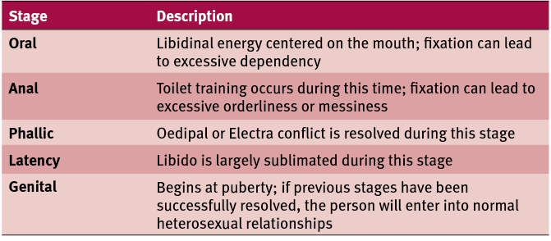

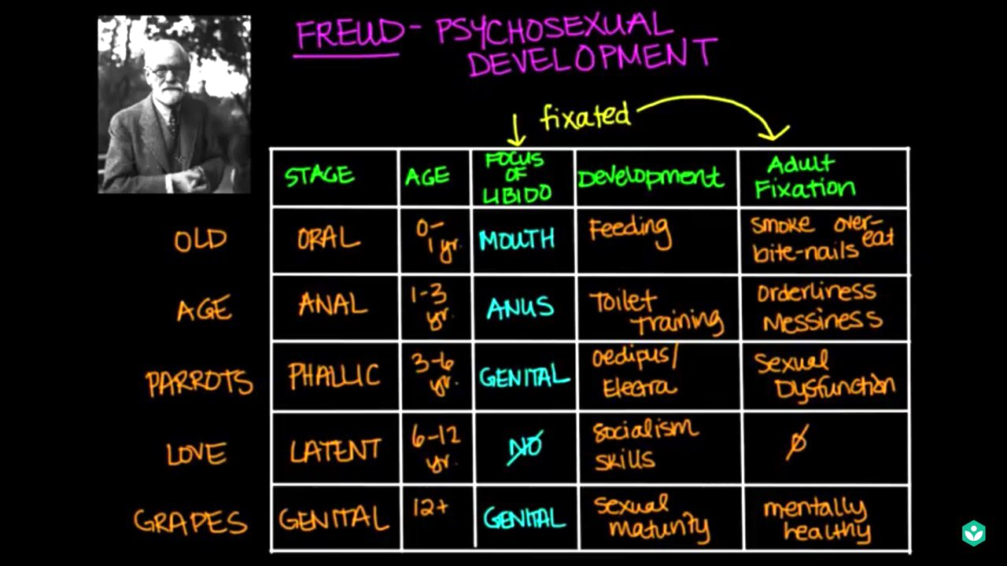

Erikson: Psychosocial Development

* Stem from **conflicts** that occur throughout life
* Conflicts are the result of decisions we are forced to make about ourselves and the environment around us at each phase of our lives
* Failure at any stage → will still continue through subsequent stages but lack the skills granted by successful resolution of that stage

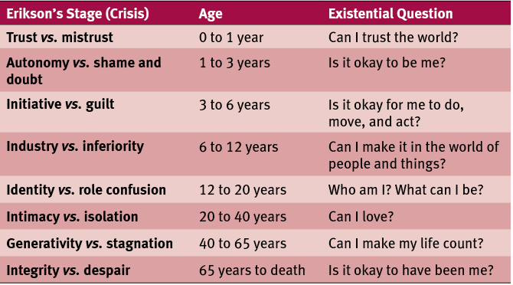

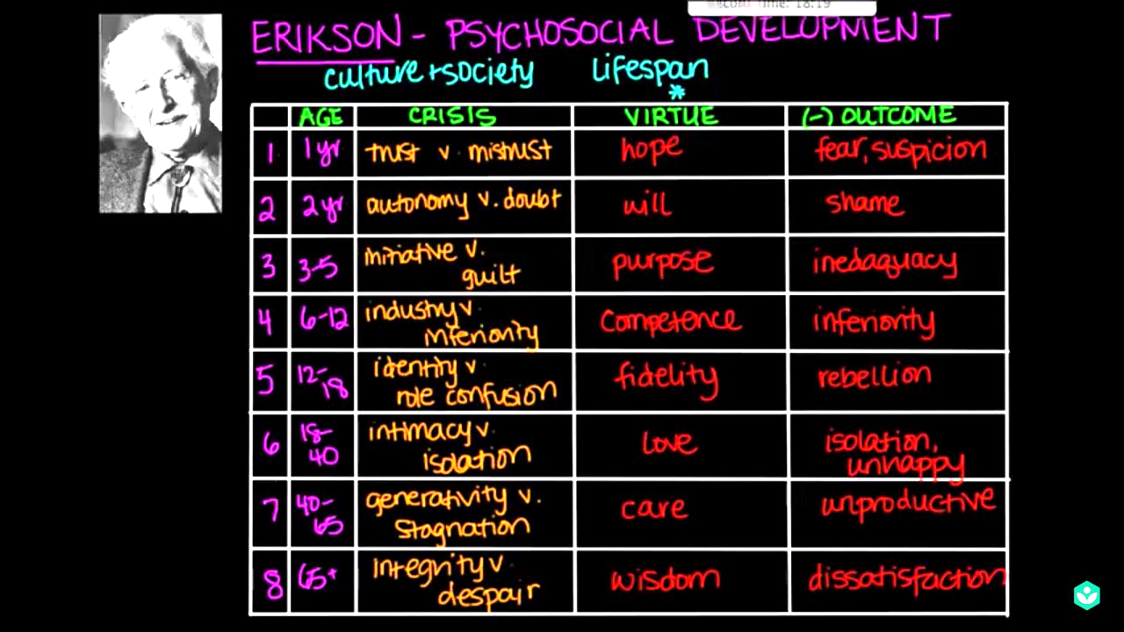

Kohlberg: Moral Reasoning

* Describes the approaches of individuals to **resolving moral dilemmas**
* Believes that we progress through six stages divided into three main phases:
  + Preconventional: Reasoning is based on individual rewards and punishments
  + Conventional: Reasoning is based on the relationship of the individual to society
  + Postconventional: Reasoning is based on abstract principles
* Failure at any stage → incapable of reasoning at that stage → will use reasoning in previous stages instead

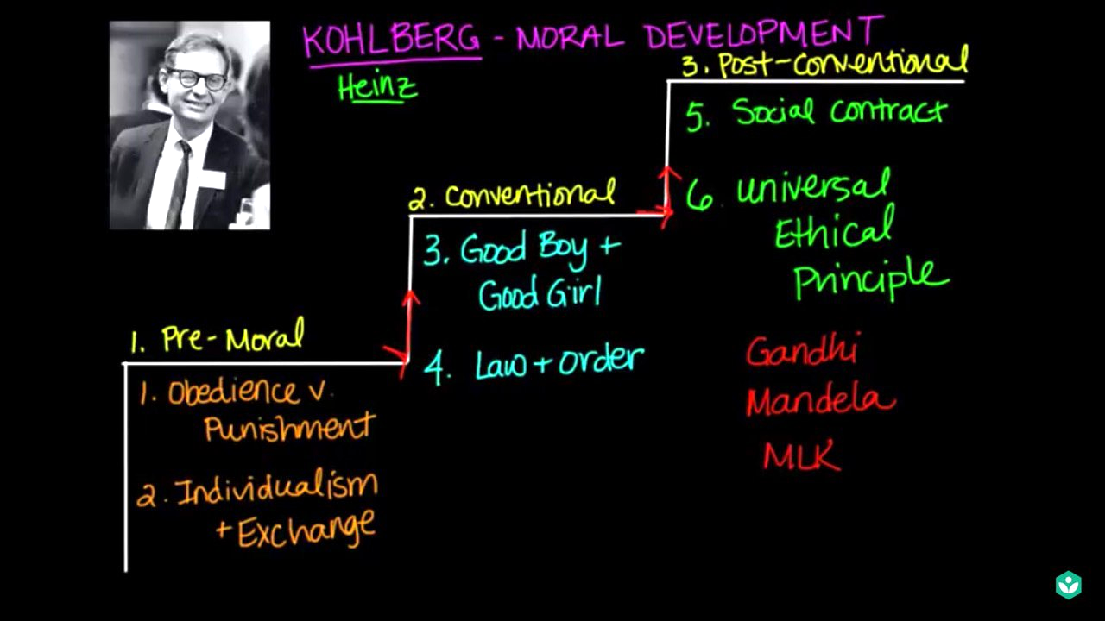

Vygotsky: Cultural and Biosocial Development

* Describes development of language, culture and skills
* Proposes the idea of the **zone of proximal development**, which describes those skills that a child has not yet mastered and require a **more knowledgeable other** to accomplish e.g. parent teaching child how to ride a bike

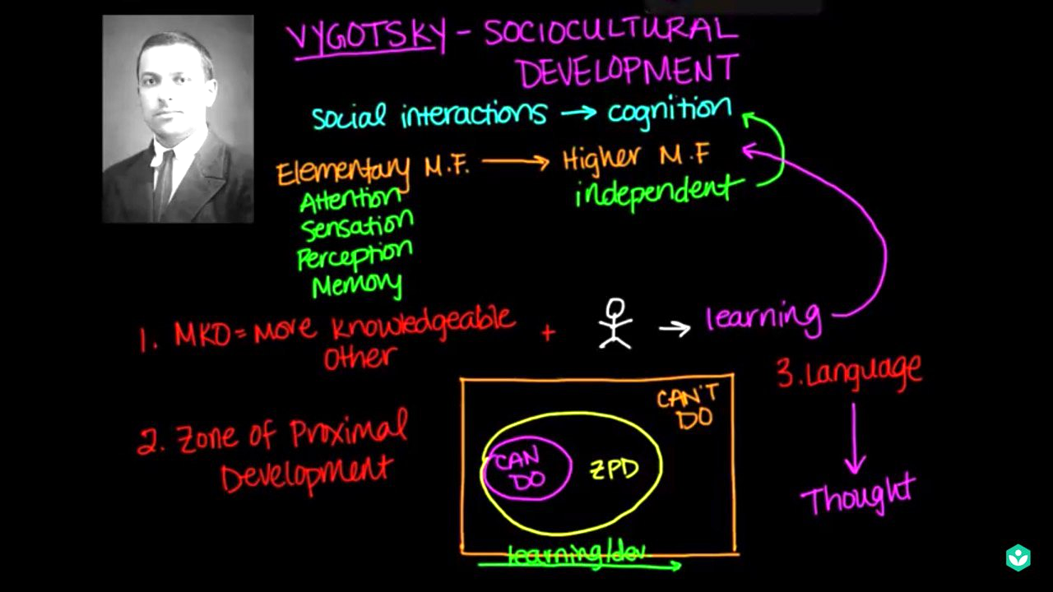

The Influence of Others on Identity

* **Imitation** and **role playing** are common ways children learn from others
* Our self-concept depends in-part on our **reference group**
  + E.g a physician (earning $200,000) thinks he is not rich (when in fact he is, when compared to median national salary) because he stays in a more affluent area

**6.3 Personality\***

* Identity describes who we are, while personality describes how we act and react to the world around us

The Psychoanalytic Perspective

* Views personality as resulting from unconscious urges and desires
  + Freud’s theory are based on:
    - Id (base urges of survival and reproduction)
    - Superego (the idealist and perfectionist)
    - Ego (the mediator between the two and the conscious mind) → makes use of **defense mechanisms** to reduce stress caused by the urges of the id and the superego

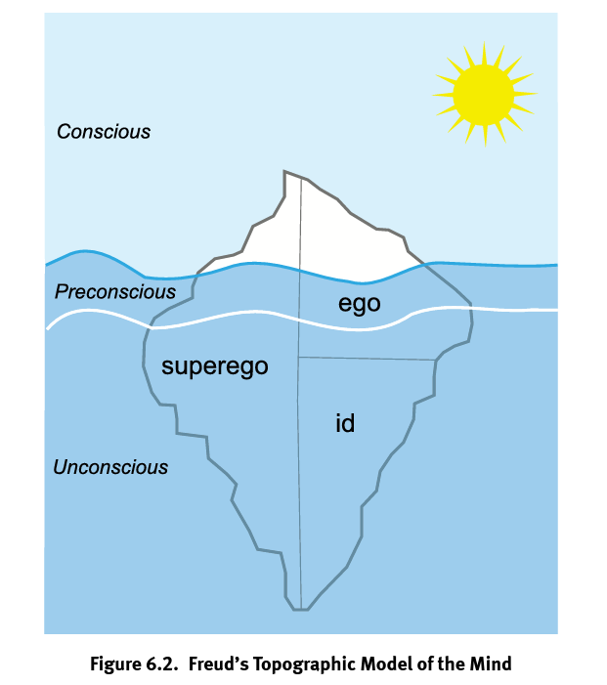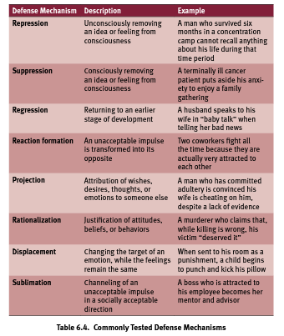

* + Jung assumed a **collective unconscious** that links all humans together, and viewed the personality as being influenced by the following **archetypes**:
    - Persona (the mask we wear in public)
    - Anima (feminine) e.g. males being emotional
    - Ani**mus** (**mus**culine) e.g. women seeking power
    - Shadow (unpleasant and socially reprehensible thoughts, feelings, and actions in our consciousness)
  + Other psychoanalysts such as Adler and Horney have distanced themselves from Freud’s theories, claiming that the unconscious is motivated by **social** rather than sexual urges

|  |  |
| --- | --- |
| **Psychoanalyst** | **Assumption** |
| Freud | Behaviour is motivated by inborn instincts |
| Jung | A person’s conduct is governed by inborn archetypes |
| Adler | People are primarily motivated by striving for superiority |

The Humanistic Perspective

* Focus on the value of individuals, instead of “sick” individuals and their troubling urges (as suggested by psychoanalysts)
* Our personality is the result of the **conscious feelings** we have for ourselves as we attempt to attain our needs and goals

1. Kurt Lewin’s **force field theory**
   * Forces grouped into two large groups: 1) those assisting in our attainment of goals, and 2) those blocking the path to them
2. Abraham Maslow’s **hierarchy of needs**
   * Self-actualized people are more likely than people who are not self-actualized to have what he called the **peak experience** (profound and deeply moving experiences)
3. George Kelly’s **personal construct psychology**
   * Her notion of psychotherapy is a process of insight whereby the individual acquires new constructs that will allow him or her to successfully predict troublesome events
   * Then the individual will be able to integrate these new constructs into already existing ones
4. Carl Rogers’ **client-centered, person-centered**, or **non-directive** therapy
   * Pioneered the concept of **unconditional positive regard** - a therapeutic technique by which the therapist accepts the client completely and expresses empathy in order to promote a positive therapeutic environment

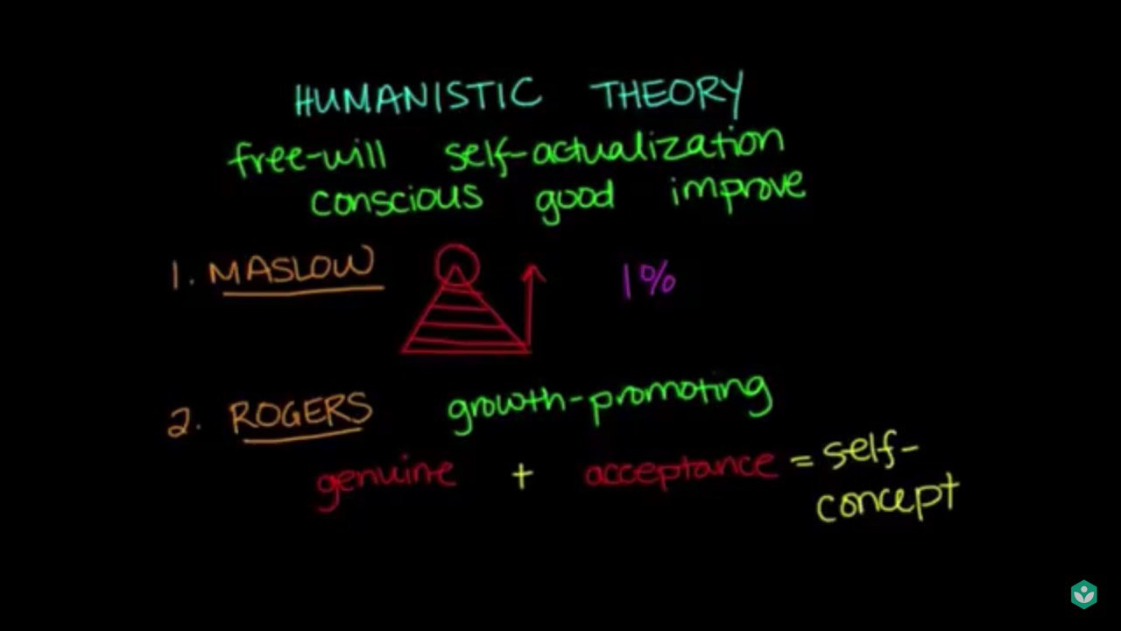

The Type and Trait Perspectives

1. Type theorists attempt to create a taxonomy of personality types, e.g. based on:
   1. Humors(blood, yellow bile, black bile, phlegm) or body fluids
   2. Somatotypes (short & stocky = jolly, tall = high-strung & aloof, the rest = strong & well-adjusted)
   3. Type A (competitive and compulsive) and Type B (laid-back and relaxed)
   4. Myers-Briggs Type Inventory (MBTI)
2. Trait theorists prefer to describe individual personality as the sum of a person’s characteristic behaviors
   1. Sybil Eysenck’s PEN theory
      1. Psychoticism (non-conformity)
      2. Extraversion (tolerance for social interaction and stimulation)
      3. Neuroticism (arousal in stressful situations)
   2. Later expanded to Big Five (OCEAN)
      1. Openness
      2. Conscientiousness
      3. Extraversion
      4. Agreeableness
      5. Neuroticism
   3. Golden Allport’s three traits
      1. Cardinal traits (how a person organizes his or her life e.g. self sacrifice for Mother Therasa)
      2. Central traits (represent major characteristics of the personality e.g. honesty or charisma)
      3. Secondary traits (more personal and are limited in occurrence)
   4. David McClelland
      1. Need for achievement (N-Ach)
      2. Avoid high risks (to avoid failing) and low risks (because easy tasks will not generate a sense of achievement) → set realistic goals and stop striving toward a goal if success is unlikely

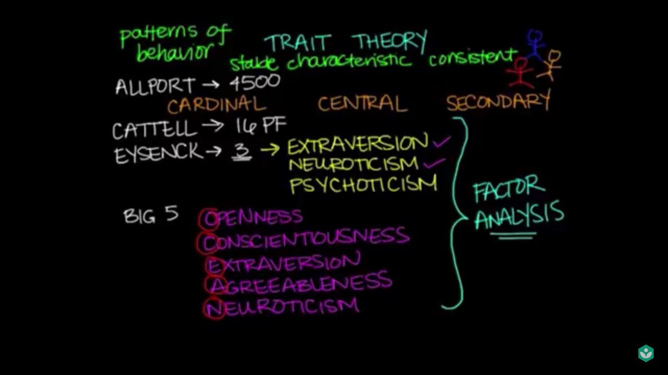

Other Theories of Personality

1. Behaviorist perspective
   1. Based on concepts of **operant conditioning** because they think personality is simply a reflection of behaviours that have been reinforced over time
   2. E.g. **token economies** are often used in inpatient therapeutic settings → positive behaviour is rewarded with tokens that can be exchanged for privileges etc
2. Social-cognitive perspective
   1. Individuals interact with their environment in a cycle
   2. Albert Bundura’s concept of **reciprocal determinism**
      1. People mold their environments according to their personalities
      2. Those environments in turn shape our thoughts, feelings and behaviors
3. Biological perspective
   1. Behaviour can be explained as a result of **genetic expression**